Q1. Develop a Single Page Application (SPA) using React that includes multiple components such as Header, Main, and Footer. Use both functional and class components and render them using JSX.
Hints:
- Use create-react-app
- Create separate components
- Use JSX syntax (<Component />)
- Combine components in App.js
- No page reload (SPA concept)
CODE:
Src/components/Header.jsx
function Header() {
return (
<header className="header">
<div className="react-logo">⚛</div>

<div className="header-content">
<h1>My React SPA</h1>
<p>Single Page Application</p>
</div>

<div className="code-icon">&lt;/&gt;</div>
</header>
);
}

export default Header;

Src/components/Footer.jsx
function Footer() {
return (
<footer className="footer">
<div className="heart">♡</div>

<p>© 2026 My React SPA. All rights reserved.</p>

<div className="social-icons">
<span>●</span>
<span>in</span>
<span>♥</span>
</div>
</footer>
);
}

export default Footer;

Src/components/Main.jsx
import React from "react";

class Main extends React.Component {
render() {
return (
<main className="main">
<div className="welcome-label">
<span></span>
WELCOME TO
<span></span>
</div>

<h2>Welcome to React</h2>

<div className="underline"></div>

<p className="description">
This is the main section of our Single Page Application.
<br />
It is built with reusable components and modern React features.
</p>

<div className="features">

<div className="feature-card">
<div className="feature-icon react-icon">⚛</div>
<h3>React</h3>
<p>
Build user interfaces with reusable components.
</p>
</div>

<div className="feature-card">
<div className="feature-icon jsx-icon">JSX</div>
<h3>JSX</h3>
<p>
Write HTML inside JavaScript with JSX syntax.
</p>
</div>

<div className="feature-card">
<div className="feature-icon component-icon">▱</div>
<h3>Components</h3>
<p>
Break UI into small, independent and reusable pieces.
</p>
</div>

<div className="feature-card">
<div className="feature-icon spa-icon">ϟ</div>
<h3>SPA</h3>
<p>
Fast, interactive and smooth Single Page Application.
</p>
</div>

</div>
</main>
);
}
}

export default Main;

App.jsx
import Header from "./components/Header";
import Main from "./components/Main";
import Footer from "./components/Footer";
import "./App.css";

function App() {
return (
<div className="app">
<Header />
<Main />
<Footer />
</div>
);
}

export default App;

OUTPUT:
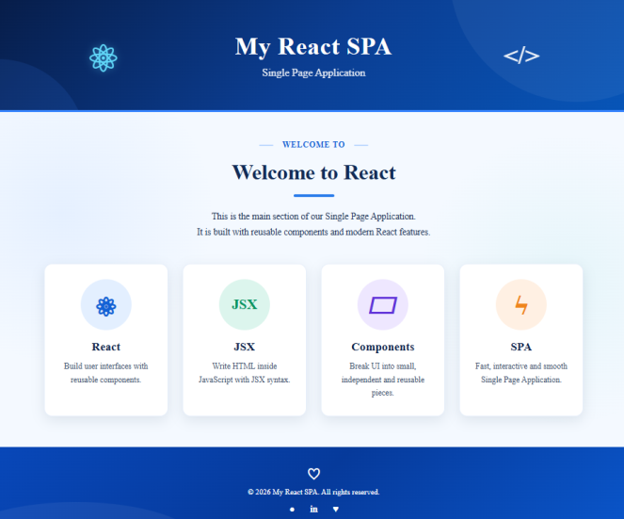

Q2. Create a React application where a parent component passes data (name, age) to a child component using props. Implement state to dynamically update the age when a button is clicked.
Hints:
- Use useState() or this.state
- Pass data using props
- Handle button click using onClick
- Re-render UI on state change
CODE:
Src/components/Parent.jsx
import { useState } from "react";
import Child from "./Child";

function Parent() {
const [age, setAge] = useState(24);

return (
<div className="parent-card">
<h2>Parent Component</h2>

<Child name="Shraddha" age={age} />

<button onClick={() => setAge(age + 1)}>
Increase Age
</button>
</div>
);
}

export default Parent;

Src/components/Child.jsx
function Child({ name, age }) {
return (
<div className="child-card">
<h3>Child Component</h3>

<p>Name: {name}</p>
<p>Age: {age}</p>
</div>
);
}

export default Child;

App.jsx
import Parent from "./components/Parent";
import "./index.css";
import "./App.css";

function App() {
return (
<div className="app">
<h1>React Props and State</h1>
<Parent />
</div>
);
}

export default App;

OUTPUT:
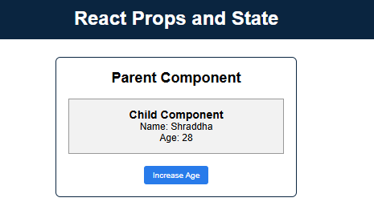
Q3. Create a class-based React component that implements lifecycle methods and handles events. Display a counter that increases when a button is clicked and log messages during component mounting and updating.
Hints:
- Use componentDidMount()
- Use componentDidUpdate()
- Initialize state in constructor
- Use onClick event handler
CODE:
App.jsx
import Counter from "./components/Counter";
import "./App.css";

function App() {
return (
<div className="app">
<h1>React Class Component</h1>

<Counter />
</div>
);
}

export default App;

arc/components/Counter.jsx
import React from "react";

class Counter extends React.Component {
constructor(props) {
super(props);

this.state = {
count: 0
};
}

componentDidMount() {
console.log("Component Mounted");
}

componentDidUpdate() {
console.log("Component Updated");
}

increaseCount = () => {
this.setState({
count: this.state.count + 1
});
};

render() {
return (
<div className="counter">
<h2>Counter: {this.state.count}</h2>

<button onClick={this.increaseCount}>
Increase Counter
</button>
</div>
);
}
}

export default Counter;

OUTPUT:
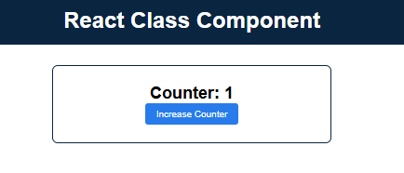

Q4. Design a React form that accepts user input (name and email). Validate the form such that empty input fields display an error message before submission.
Hints:
- Use controlled components
- Use useState() for form data
- Handle input with onChange
- Handle submit with onSubmit
- Use conditional rendering for errors
CODE:
App.jsx
import Form from "./components/Form";
import "./App.css";

function App() {
return (
<div className="app">
<h1>React Form Validation</h1>
<Form />
</div>
);
}

export default App;

Arc/components/Form.jsx
import { useState } from "react";

function Form() {
const [name, setName] = useState("");
const [email, setEmail] = useState("");
const [error, setError] = useState("");

const handleSubmit = (e) => {
e.preventDefault();

if (name === "" || email === "") {
setError("Please fill in all fields.");
} else {
setError("");
alert("Form submitted successfully!");
}
};

return (
<form onSubmit={handleSubmit}>
<h2>User Form</h2>

<label className="form-label">Name:</label>
<br />
<input
type="text"
value={name}
onChange={(e) => setName(e.target.value)}
/>

<br /><br />

<label>Email:</label>
<br />
<input
type="email"
value={email}
onChange={(e) => setEmail(e.target.value)}
/>

<br /><br />

{error && <p className="error">{error}</p>}

<button type="submit">Submit</button>
</form>
);
}

export default Form;

OUTPUT:
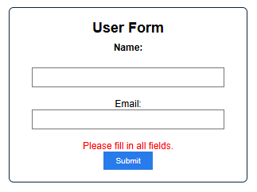
Q5.Create a React application that dynamically updates the UI using state and applies inline styling. Demonstrate how UI updates efficiently without reloading the page.
Hints:
- Use useState() for dynamic changes
- Apply inline styles using { }
- Trigger UI update using button click
- Understand Virtual DOM re-rendering
CODE:
import { useState } from "react";

function App() {
const [count, setCount] = useState(0);

const boxStyle = {
padding: "20px",
margin: "30px auto",
width: "300px",
border: "2px solid #0a2540",
textAlign: "center"
};

return (
<div style={{ textAlign: "center", fontFamily: "Arial" }}>
<h1 style={{ backgroundColor: "#0a2540", color: "white", padding: "15px" }}>
Dynamic UI using State
</h1>

<div style={boxStyle}>
<h2>Count: {count}</h2>

<button
onClick={() => setCount(count + 1)}
style={{
padding: "8px 15px",
backgroundColor: "#287bea",
color: "white",
border: "none",
cursor: "pointer"
}}
>
Increase Count
</button>
</div>
</div>
);
}

export default App;

OUTPUT:
